**Assignment -2**

**Python program**

|  |  |
| --- | --- |
| **Assignment Date** | 24 September 2022 |
| **Student name**  **Student Roll No**  **Maximum Marks** | Sowmiya N  710019106044  2 Marks |

**1.Build a python code:**

Assume u get a temperature and humidity values (generated with random function to a Variable) and write a condition to continuously detect an alarm in case of high temperature.

**CODE SOLUTION:**

import random

def temperature ():

value=random.randint(25,100)

return value

t=temperature ()

t=int (input("Enter the temperature value"))

def humidity ():

range=random.randint(40,100)

return range

h=humidity ()

h=int (input("Enter the humidity value"))

if t>30:

print ("High temperature detected")

print ("Buzzer on, alarm sound is high")

elif t==30:

print ("Temperature reached maximum threshold of 30 degree Celsius")

else:

print ("Temperature is good")

#For Humidity

if h>65 :

print ("High humidity detected")

print("Buzzer on, alarm sound is high")

elif h == 65:

print ("Humidity reached maximum threshold of 65 percent")

else:

print ("Humidity is good")

**Program:** 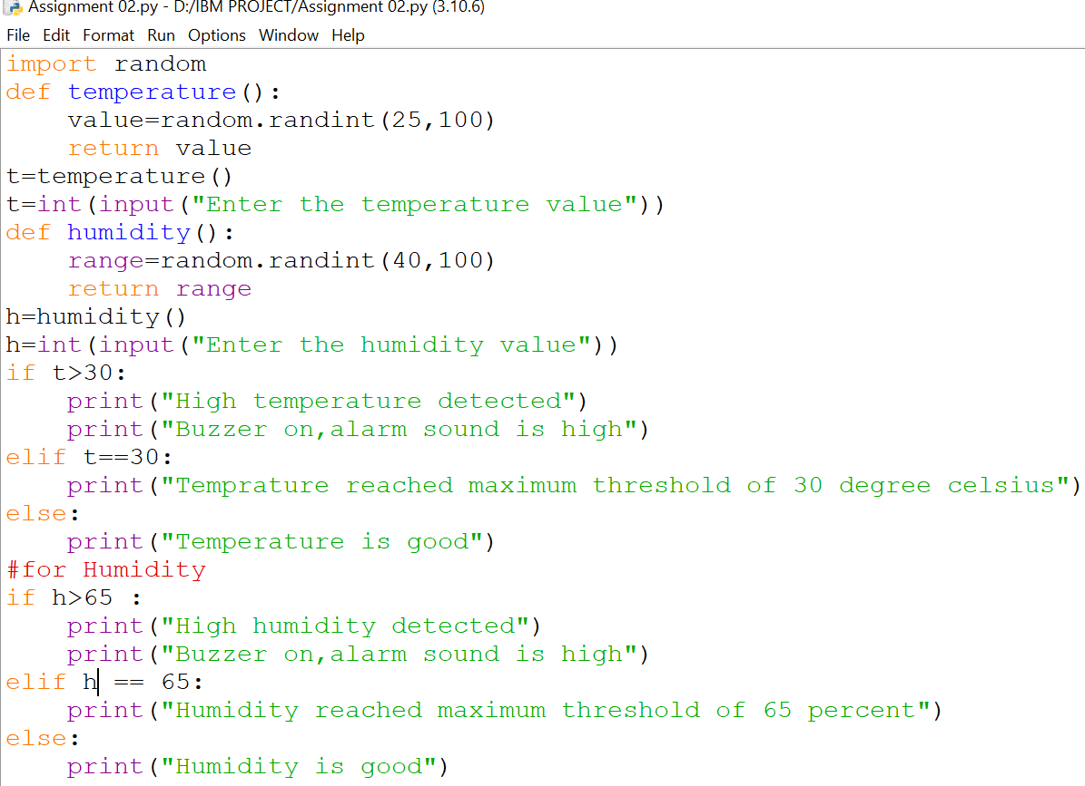

**Output:**

